Nama : Nizar Ali Rifai  
Kelas : XI RPL 6  
Absen : 24

**Tugas Dashboard Design (Individu)**

1. Hasil Running Screenshot

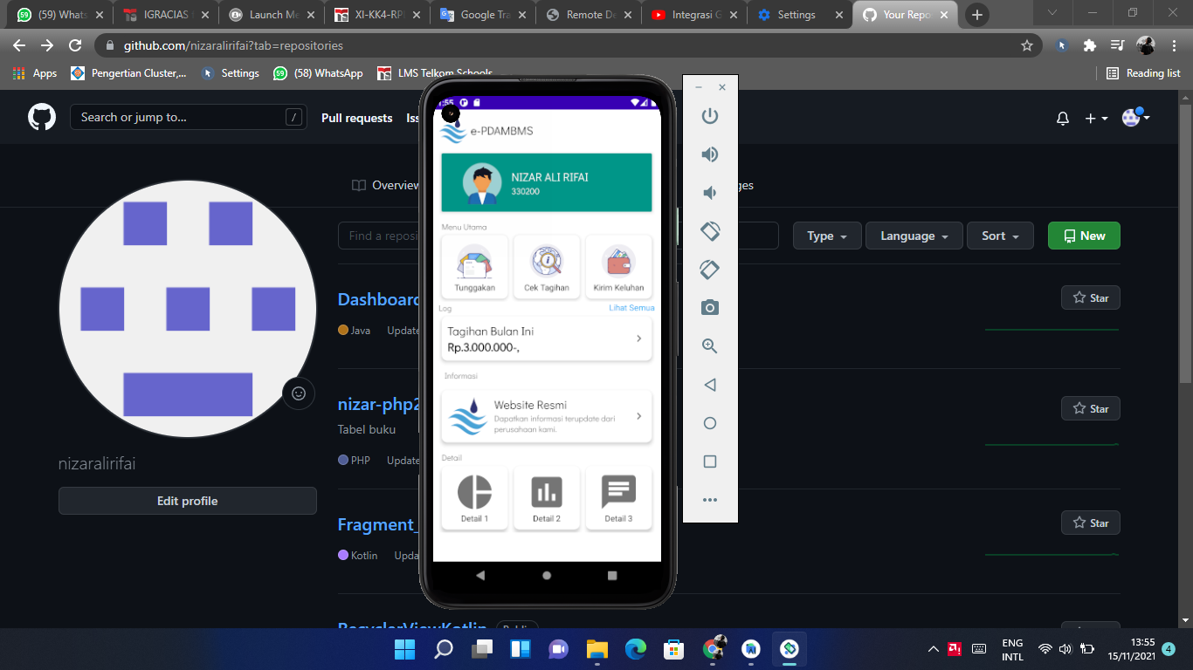

1. Link Github :

https://github.com/nizaralirifai/Dashboard_Nizar_24